**K CHAITHANYA SAI 52**

**K AMITH REDDY 26**

**VAMSI KRISHNA 36**

**B.V.N.KARTHIK 16**

**Abstract**

**EXPLICIT FINITE DIFFERENCE METHOD , CRANK-NICOLSON METHOD ALONG WITH EXAMPLES**

**NUMERICAL SOLUTION OF PARTIAL DIFFERENTIAL EQUATIONS**

**HEAT EQUATION**

# Partial Differential Equations

A *partial differential equation* (PDE) is an equation that involves an unknown function (the dependent variable) and some of its partial derivatives with respect to two or more independent variables. An *n*th-order equation has the highest order derivative of order *n*.

## 2.1 Classical Equations of Mathematical Physics

1. Laplace’s equation (the potential equation)

|  |  |
| --- | --- |
| ∇2*φ* = 0  In Cartesian coordinates, the vector operator *del* is defined as |  |

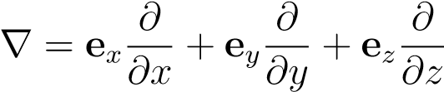*.*

∇2 is referred to as the Laplacian operator and given by

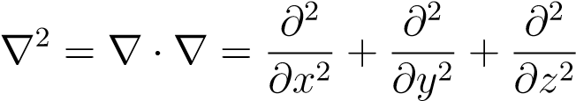*.*

Thus, Laplace’s equation in Cartesian coordinates is

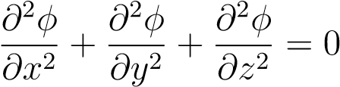*.*

Laplace’s equation arises in incompressible fluid flow (in which case *φ* is the velocity potential), gravitational potential problems, electrostatics, magnetostatics, steady-state heat conduction with no sources (in which case *φ* is the temperature), and torsion of bars in elasticity (in which case *φ*(*x,y*) is the warping function). Functions which satisfy Laplace’s equation are referred to as *harmonic* functions.

1. Poisson’s equation

∇2*φ* + *g* = 0

This equation arises in steady-state heat conduction with distributed sources (*φ* = temperature) and torsion of bars in elasticity (in which case *φ*(*x,y*) is the stress function).

1. wave equation

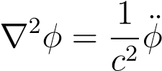

In this equation, dots denote time derivatives, e.g.,

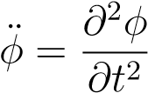*,*

and *c* is the speed of propagation. Heat equation

∇· (*k*∇*φ*) + *Q* = *ρcφ*

In this equation, *φ* represents the temperature *T*, *k* is the thermal conductivity, *Q* is the internal heat generation per unit volume per unit time, *ρ* is the material density, and *c* is the material specific heat (the heat required per unit mass to raise the temperature by one degree). The thermal conductivity *k* is defined by Fourier’s law of heat conduction:

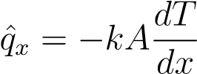*,*

where *q*ˆ*x* is the rate of heat conduction (energy per unit time) with typical units J/s or BTU/hr, and *A* is the area through which the heat flows. Alternatively, Fourier’s law is written

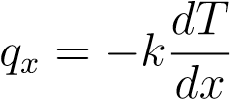*,*

where *qx* is energy per unit time per unit area (with typical units J/(s·m2).

There are several special cases of the heat equation of interest:

(a) homogeneous material (*k* = constant):

|  |
| --- |
| *k*∇2*φ* + *Q* = *ρcφ*˙  (b) homogeneous material, steady-state ( time-independent ): |

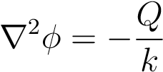 (Poisson’s equation)

|  |  |
| --- | --- |
| (c) homogeneous material, steady-state, no sources (*Q* = 0): |  |
| ∇2*φ* = 0 (Laplace’s equation) |  |

## Classification of Partial Differential Equations

Of the classical PDEs summarized in the preceding section, some involve time, and some don’t, so presumably their solutions would exhibit fundamental differences. Of those that involve time (wave and heat equations), the order of the time derivative is different, so the fundamental character of their solutions may also differ. Both these speculations turn out to be true.

Consider the general, second-order, linear partial differential equation in two variables

*Auxx* + *Buxy* + *Cuyy* + *Dux* + *Euy* + *Fu* = *G, (1)*

where the coefficients are functions of the independent variables *x* and *y* (i.e., *A* = *A*(*x,y*) , *B* = *B*(*x,y*), etc.

The quantity *B*2 − 4*AC* is referred to as the *discriminant* of the equation.

The behavior of the solution of Eq.(1) depends on the sign of the discriminant according to the following table:

*B*2 − 4*AC* Equation Typ Typical Physics Described

*<* 0 Elliptic Steady-state phenomena

= 0 Parabolic Heat flow and diffusion processes

*>* 0 Hyperbolic Vibrating ystems and wave motion

The names elliptic, parabolic, and hyperbolic arise from the analogy with the conic sections in analytic geometry.

Given these definitions, we can classify the common equations of mathematical physics already encountered as follows:

Name Eq. in Two Variables *A,B,C* Type

Laplace *uxx* + *uyy* = 0 *A* = *C* = 1*,B* = 0 Elliptic

Poisson *uxx* + *uyy* = −*g A* = *C* = 1*,B* = 0 Elliptic

Wave *uxx* − *uyy/c*2 = 0 *A* = 1*,C* = −1*/c*2*,B* = 0 Hyperbolic

Helmholtz *uxx* + *uyy* + *k*2*u* = 0 *A* = *C* = 1*,B* = 0 Elliptic

Heat *kuxx* − *ρcuy* = −*Q A* = *k,B* = *C* = 0 Parabolic

In the wave and heat equations in the above table, *y* represents the time variable. The behavior of the solutions of equations of different types differs. Elliptic equations characterize static (time-independent) situations, and the other two types of equations characterize time dependent situations.

#### **Explicit Finite Difference Method**

Let *ui,j* be the numerical approximation to *u*(*xi,tj*). We approximate *ut* with the forward finite difference

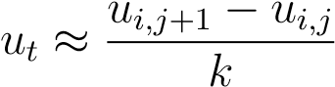

and *uxx* with the central finite difference

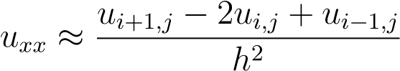

The finite difference approximation to the PDE is then

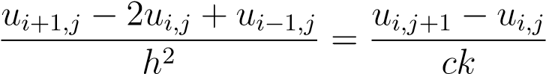 (2)

Define the parameter *r* as

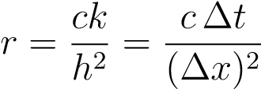

in which case Eq. (2) becomes

***ui,j*+1 = *rui*−1*,j* + (1 − 2*r*)*ui,j* + *rui*+1*,j***

-

6

*x*

*t*

0

1

*u*

=

*f*

(

*x*

)

*u*

0

=

*u*

=

0

s

*i*

−

1

*,j*

s

*i,j*

s

*i*

+1

*,j*

s

*i,j*

+1

*h*

?

6

*k*

Figure 5: Mesh for 1-D Heat Equation.

Notice that, if *r* = 1*/*2, the solution at the new point is *independent* of the closest point. For *r >* 1*/*2 (e.g., *r* = 1), the new point depends *negatively* on the closest point, which is counter-intuitive. It can be shown that, for a stable solution, 0 *< r* ≤ 1*/*2. An unstable solution is one for which small errors grow rather than decay as the solution evolves.The instability which occurs for *r >* 1*/*2.

***Crank Nicolson Method***

The Crank-Nicolson method is a stable algorithm which allows a larger time step than could be used in the explicit method. In fact, Crank-Nicolson’s stability does not depend on the parameter *r*.

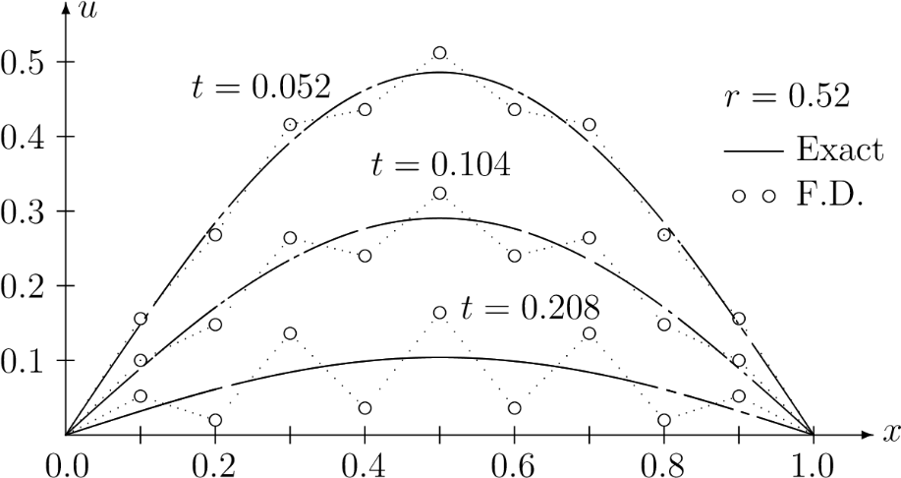

Figure 10: Explicit Finite Difference Solution With *r* = 0*.*52.

The basis for the Crank-Nicolson algorithm is writing the finite difference equation at a mid-level in time: . The finite difference *x* derivative at is computed as the average of the two central difference time derivatives at *j* and *j*+1.

Consider again the PDE,

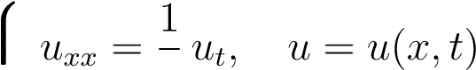

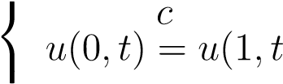) = 0 (boundary conditions)

*u*(*x,*0) = *f*(*x*) (initial condition)*.*

The PDE is approximated numerically by



where the right-hand side is a central difference approximation to the time derivative at the middle point. We again define the parameter *r* as

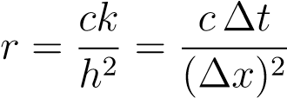*,*

and rearrange Eq with all *j* + 1 terms on the left-hand side:

**− *rui*−1*,j*+1 + 2(1 + *r*)*ui,j*+1 − *rui*+1*,j*+1 = *rui*−1*,j* + 2(1 − *r*)*ui,j* + *rui*+1*,j.***

This formula is called the *Crank-Nicolson* algorithm.

Fig. 11 shows the points involved in the Crank-Nicolson scheme. If we start at the bottom row (*j* = 0) and move up, the right-hand side values of Eq. 3.13 are known, and the left-hand side values of that equation are unknown. To get the process started, let *j* = 0, and write the C-N equation for each *i* = 1*,*2*, ...,N* to obtain *N* simultaneous equations in *N* unknowns, where *N* is the number of *interior* mesh points on the row. (The boundary points, with known values, are excluded.) This system of equations is a tridiagonal system, since each equation has three consecutive nonzeros centered around the diagonal. To advance in time,

-

6

*x*

*t*

0

1

*u*

=

*f*

(

*x*

)

*u*

0

=

*u*

0

=

s

*i*

−

1

*,j*

s

*i,j*

s

*i*

+1

*,j*

s

*i*

−

1

*,j*

+1

s

*i,j*

+1

s

*i*

+1

*,j*

+1

d

*h*

?

6

*k*

Figure Mesh for Crank-Nicolson.

THANK YOU